SELECT COUNT(u_id), address

FROM users

GROUP BY address;

SELECT MAX(u_id), user_category

FROM users

GROUP BY user_category;

SELECT address,COUNT(*) FROM users GROUP BY address;

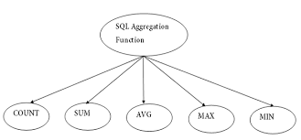

SELECT fname,email FROM users

ORDER BY fname DESC;

SELECT lname FROM users

ORDER BY lname ASC;

CREATE INDEX fname ON users (fname(10));

SELECT url, class, email FROM books CROSS JOIN users

SELECT * FROM user_category CROSS JOIN word_doc

SQL Aliases

SQL aliases are used to give a table, or a column in a table, a temporary name.

Aliases are often used to make column names more readable.

An alias only exists for the duration of that query.

An alias is created with the AS keyword.

SELECT productname AS myproducts

FROM products;